**Programming Fundamentals**

**Lab Report**

**Lab03**



|  |  |
| --- | --- |
| Group Members Name & Reg #: | **Muhammad Haris Irfan**  **(FA18-BCE-090)** |
|  |  |
| Class | Programming Fundamentals CSC103 (**BCE-2B**) |
| Instructor’s Name | Dilshad Sabir |

**In Lab Tasks**

**Question no: 1**

Write a C program that solves a simple user-entered mathematical expression. It should take input from the user (two floating type values and operations like *, /, + and -), calculate the result and show it on screen.

**Solution:**

In this Program, I used Switch and Case Operators, I made a separate Case for each of multiplication, addition, subtraction and division.

Code and results attached below

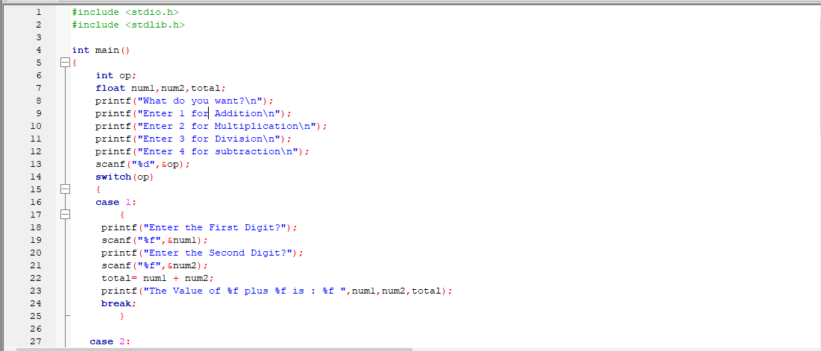I tested my program with N as 1 and M as 10, the result is attached below,

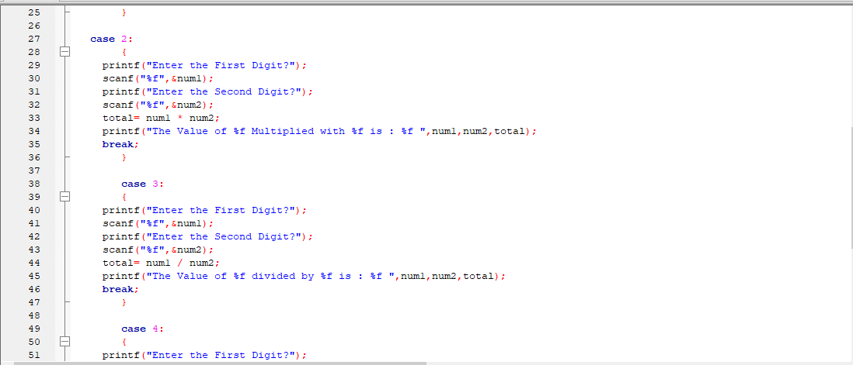

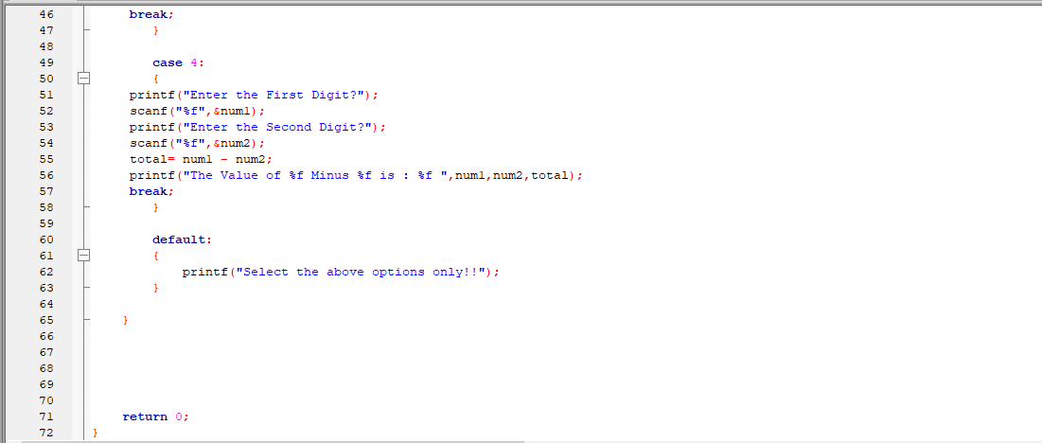

_____________________________

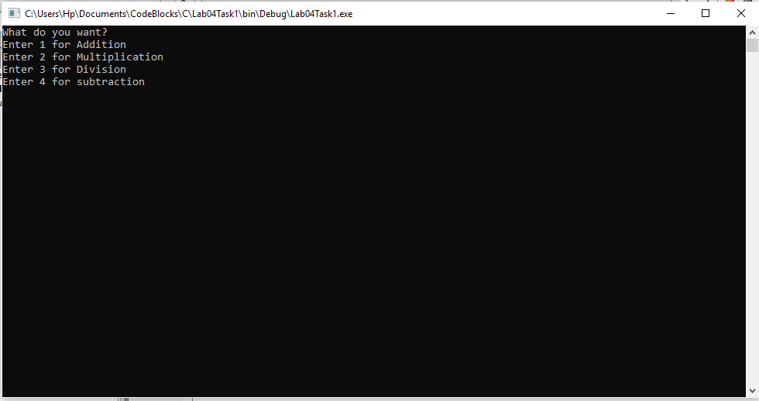Now below is the Menu:

**Now I have Tested all 4 for different values, there result is attached below,**

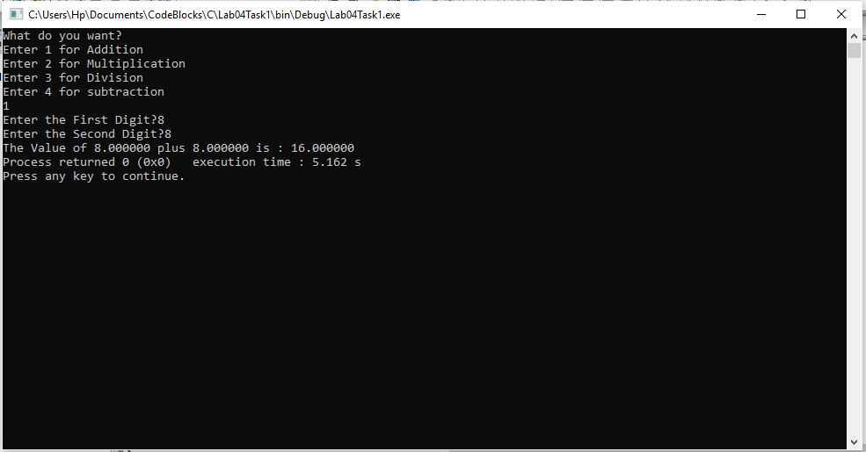

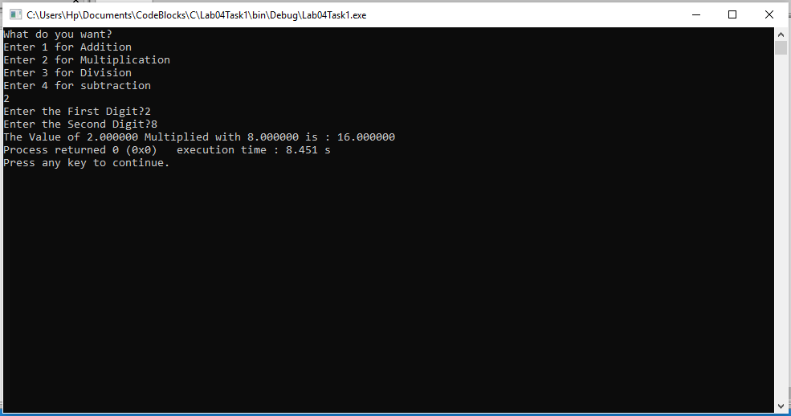

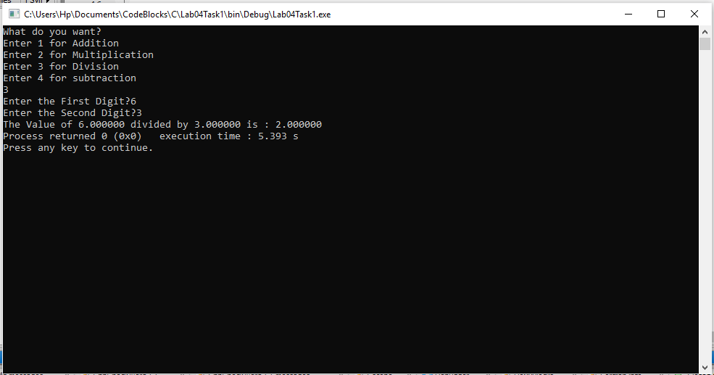

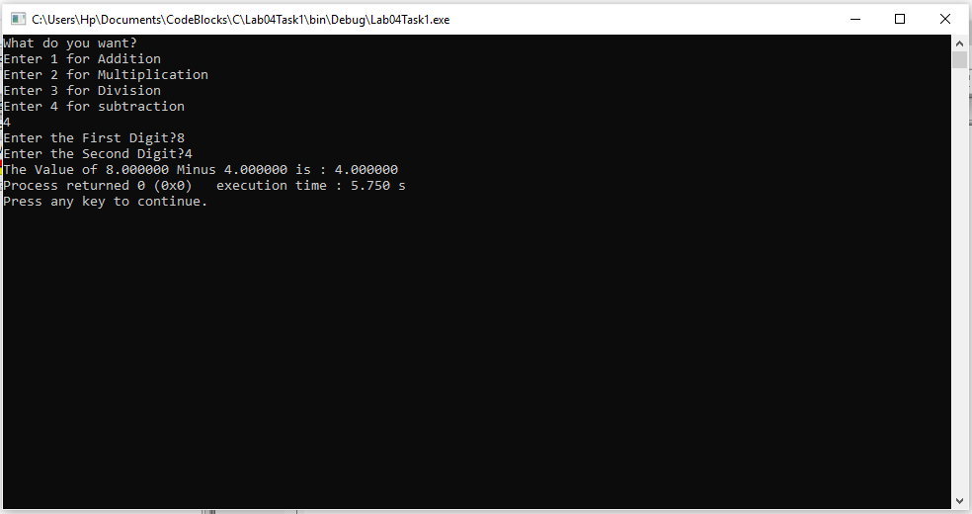

Hence, these results further verify the that our program works for all values and is correct.

-------------------------------

**Question no: 2(a)**

Following program prints a menu. It then takes input from user and displays the entered choice. Type-in the C program given below into a new project, compile and run to see how it works..

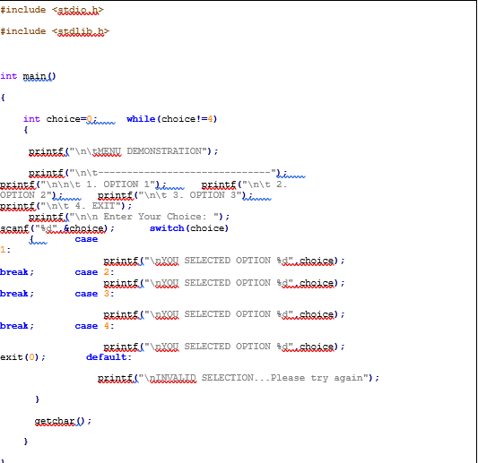

Solution

I compiled and ran the following program in codeblocks, its result is attached below,

This is the menu,

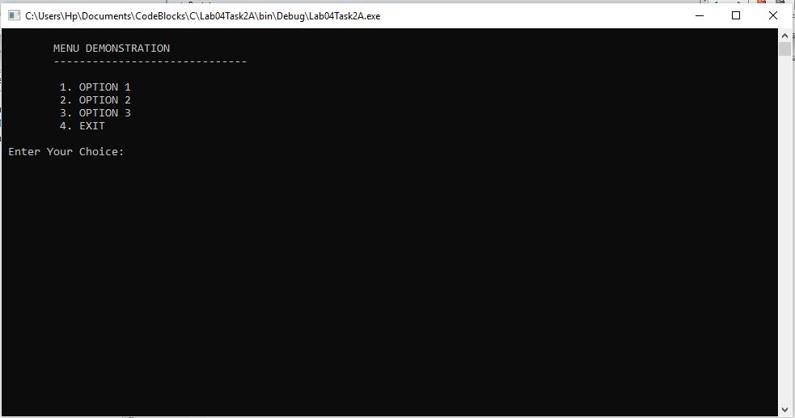

It tells us which option we selected when we enter an option, for eg:

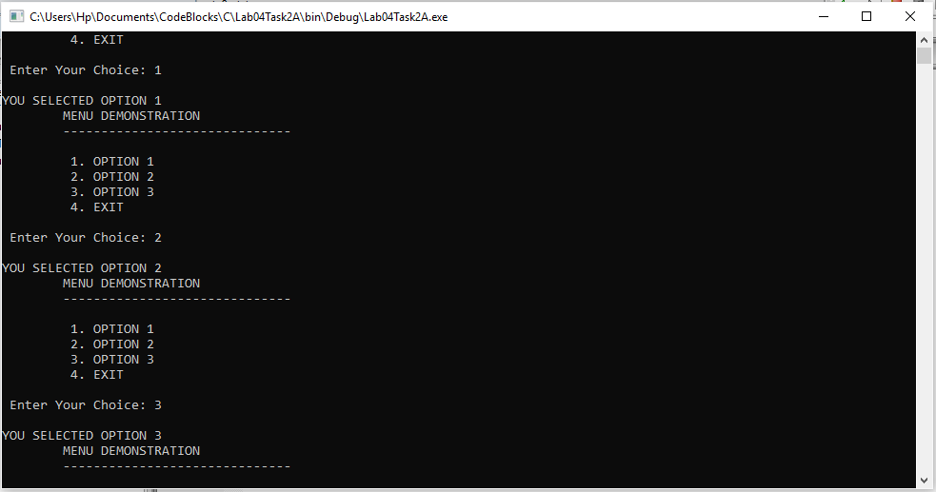

Hence, this verifies our program.

-------------------------------

**Question no: 2(b)**

Modify the above program to implement following sate machine. Here ***‘a’*** and ***‘b’*** are user input characters. The program should print out appropriate messages to the console when a user enters a character.

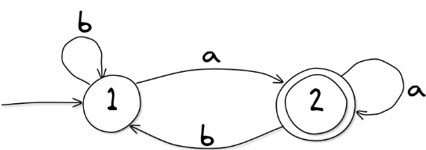

**Solution**

In this program I used switch and case statements as well as the goto statement, initially we are in state one, if the user inputs ***‘a’***, state is changed to 2, if *‘****b’*** is entered the state is not changed, similarly when in state 2, if the user enters ‘***b’*** then state is changed and if ***‘a’*** is entered the state remains same.

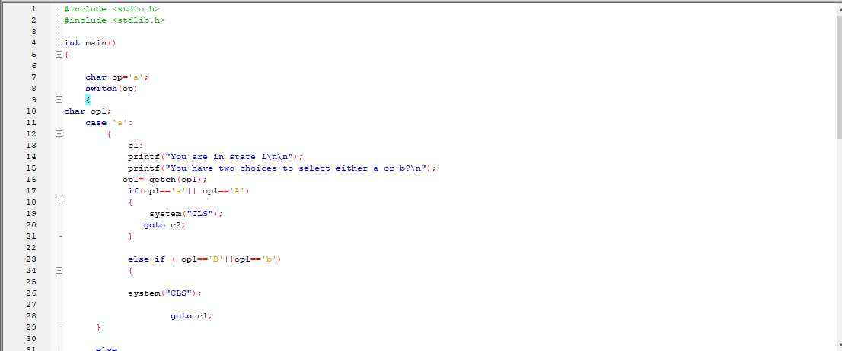The code and results are attached below,

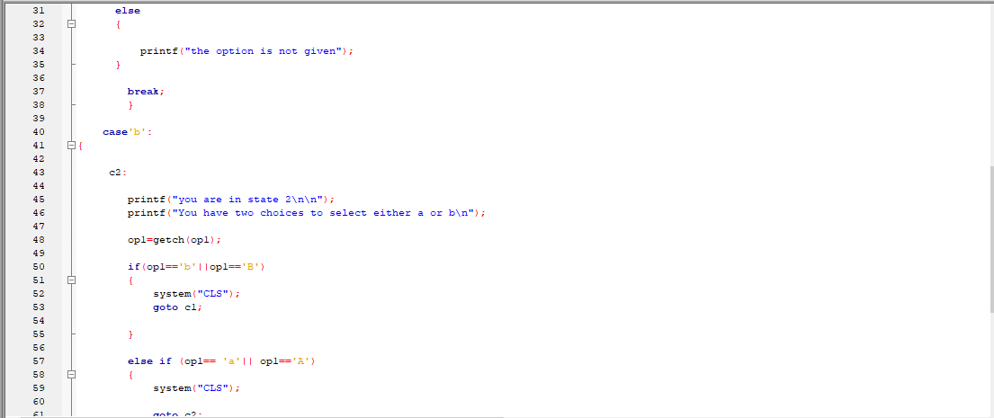

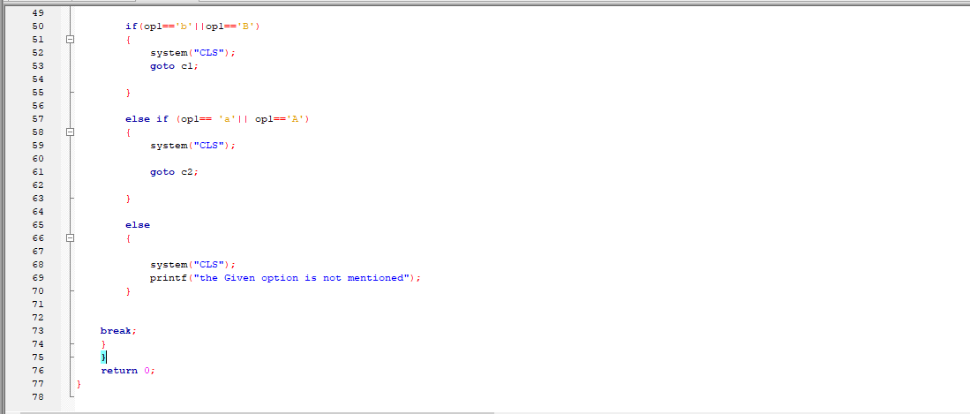

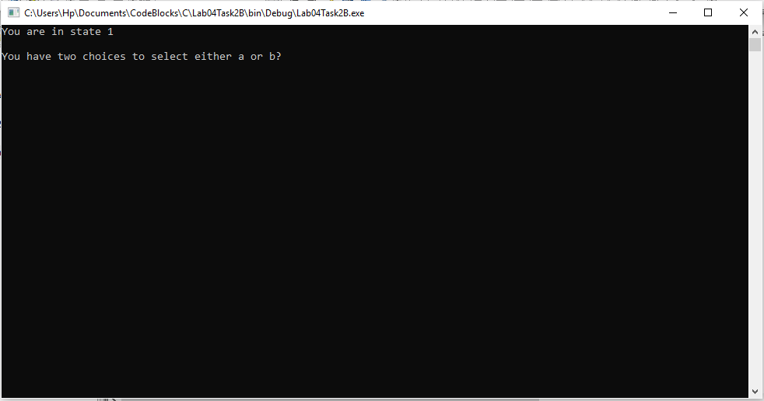Now, initially we are in state 1,

When b is pressed the state changes to 2.

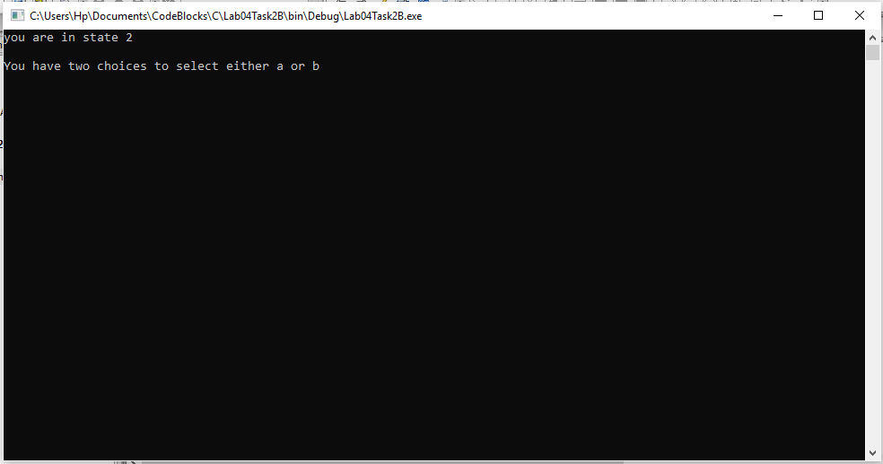

and this is also valid vice versa, the above results show that our program is valid and correct.

-------------------------------

POST LAB

Question:

Write a C program to implement the following state machine.

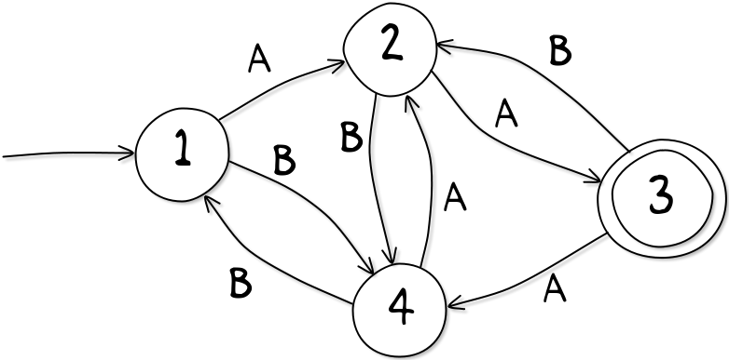

Solution:

I am attaching my code below for this program, its code is similar to the above program, I used case and goto statements in this program.

The code and result is attached below,

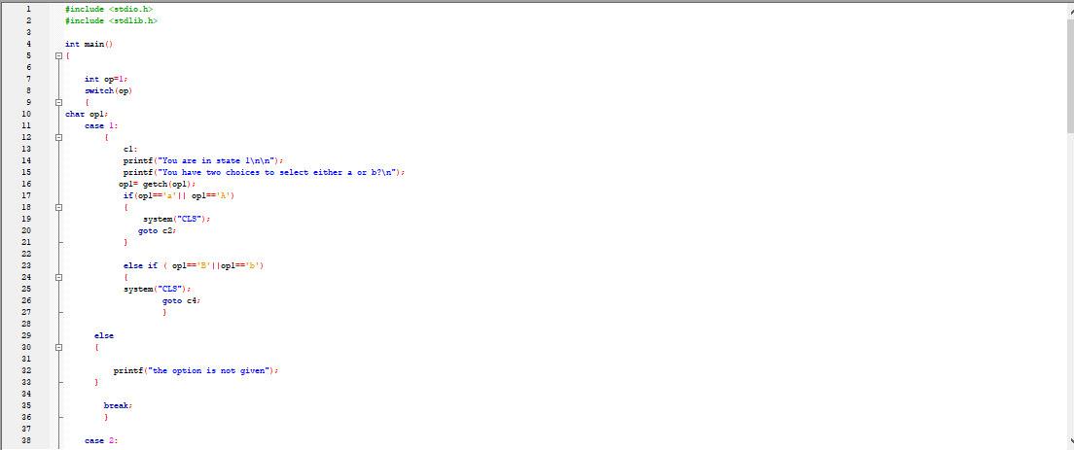

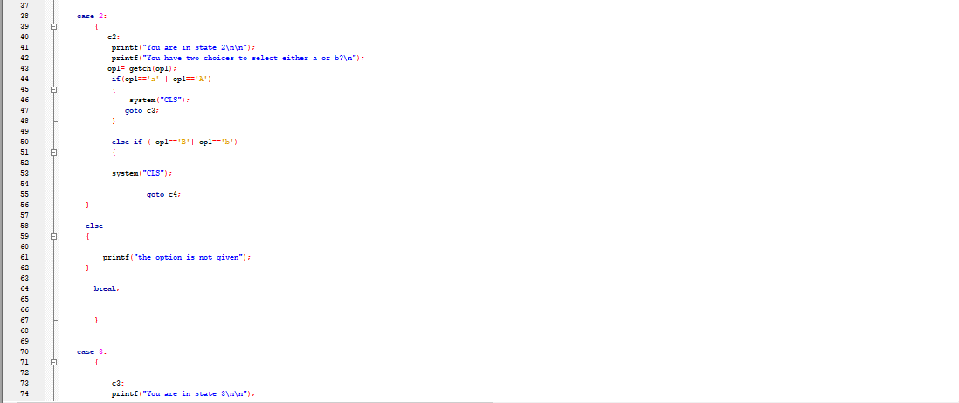

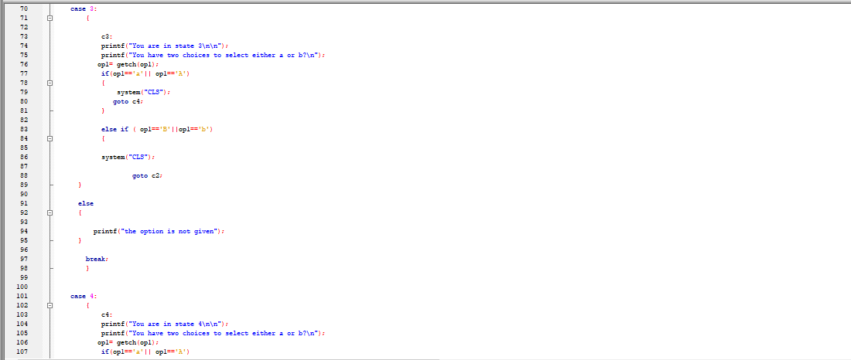

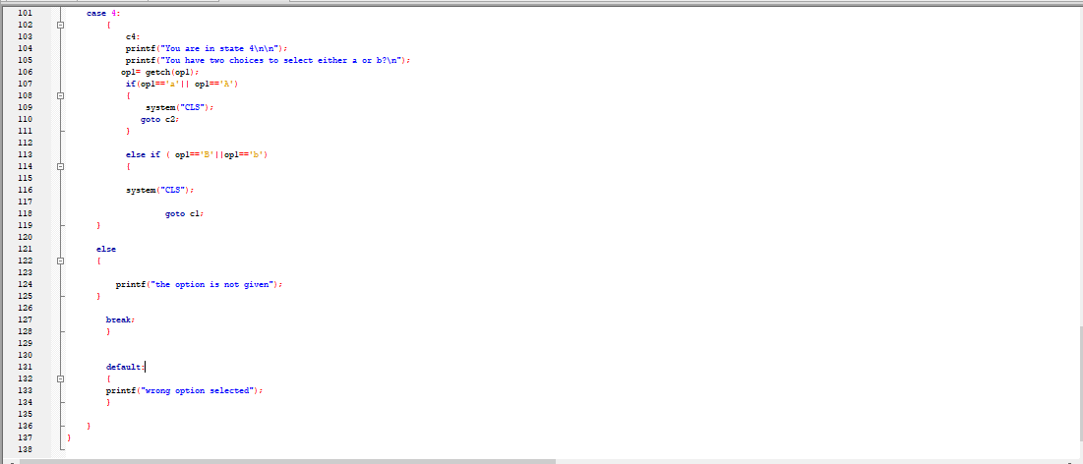

When we press a in state 1, it goes to state b

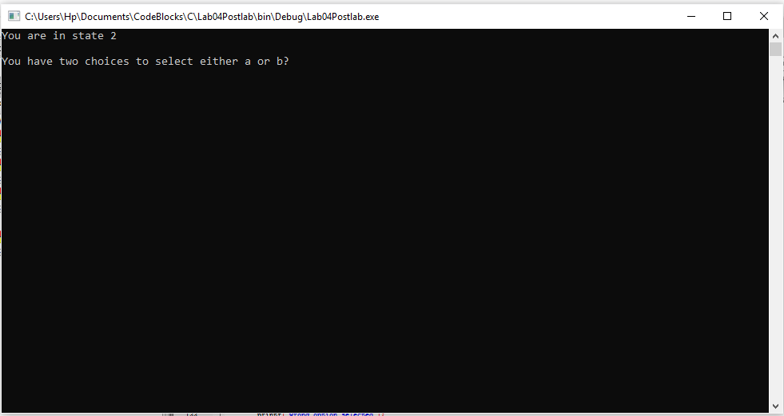

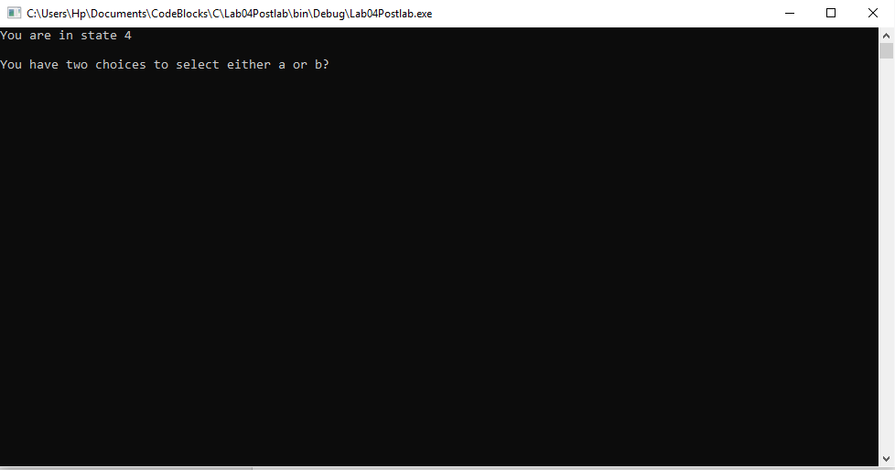when I press b in state 2 it goes to state 4

Hence, The working shows that our code works for all states and is correct.

-------------------------------

THE END